**Step 1: Create an Amazon RDS MySQL Instance**

1. **Log in to AWS Console**:
   * Go to the [AWS Management Console](https://aws.amazon.com/console/) and log in with your credentials.
2. **Navigate to RDS Service**:
   * In the AWS Console, search for **RDS** in the search bar and select **RDS** from the list of services.

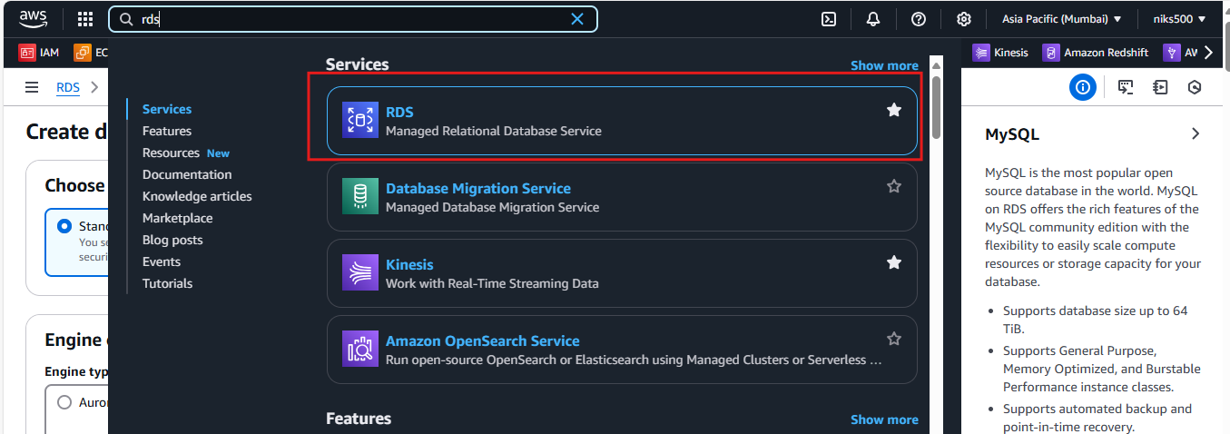

1. **Launch a New RDS Instance**:
   * Click on **Databases** in the left-hand menu.
   * Click on the **Create database** button to create a new RDS instance.

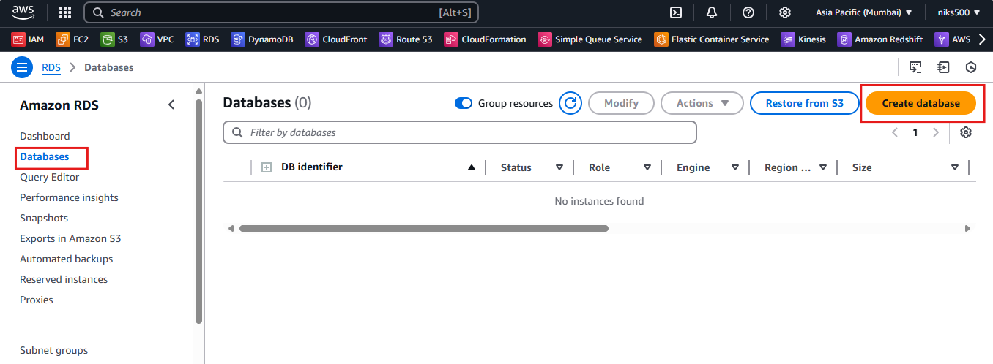

1. **Choose Database Engine**:
   * Select **MySQL** as the database engine.

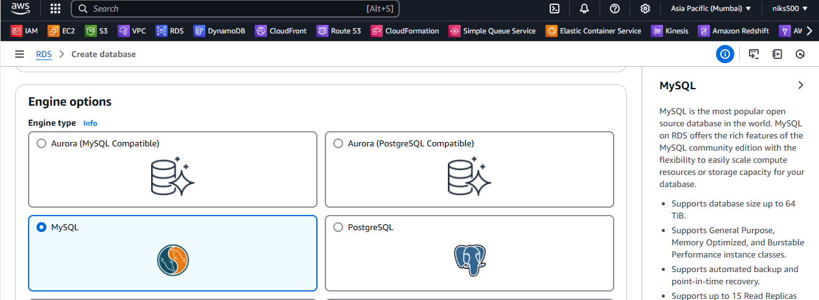

1. **Choose a Template**:
   * Choose the **Free tier** (if eligible) for testing purposes or **Production** for a more robust setup.

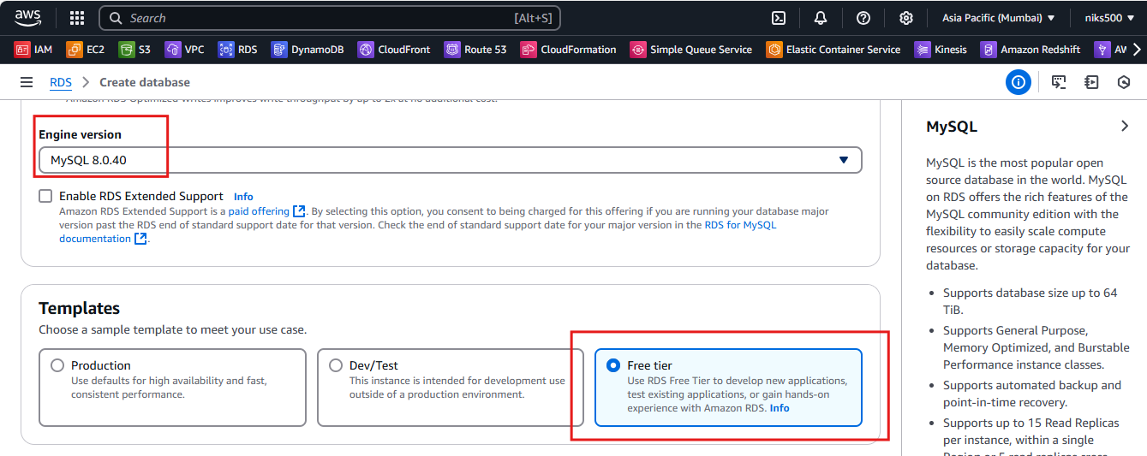

1. **Configure the Database**:
   * **DB Instance Identifier**: Give your instance a unique name (e.g., my-mysql-db).
   * **Master Username**: Choose a master username (e.g., admin).
   * **Master Password**: Enter a strong password and confirm it.

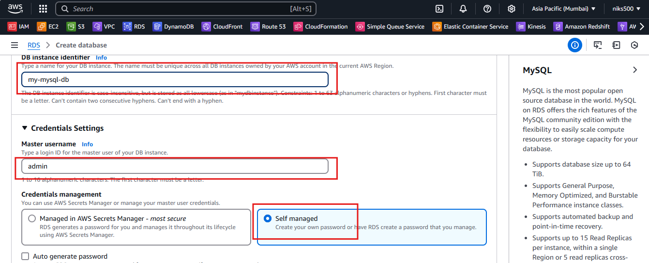

1. **Choose Instance Size**:
   * For a small test database, you can choose **db.t3.micro** (Free Tier eligible).

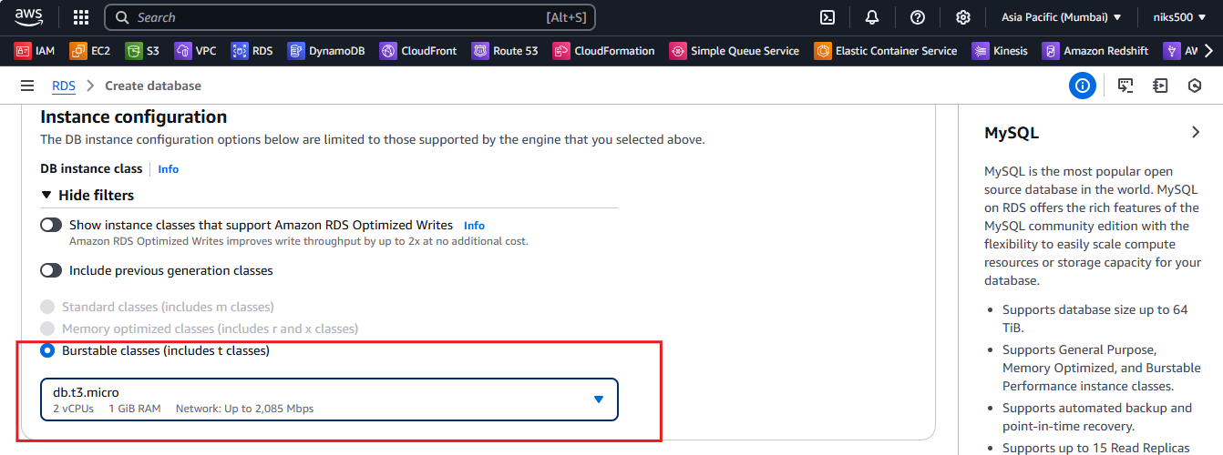

1. **Configure Connectivity**:
   * **VPC**: Select the default VPC or create a custom one.
   * **Subnet**: Select a subnet that can allow access.
   * **Public Accessibility**: Set to **Yes** to make the database accessible from outside AWS (needed for DBeaver).

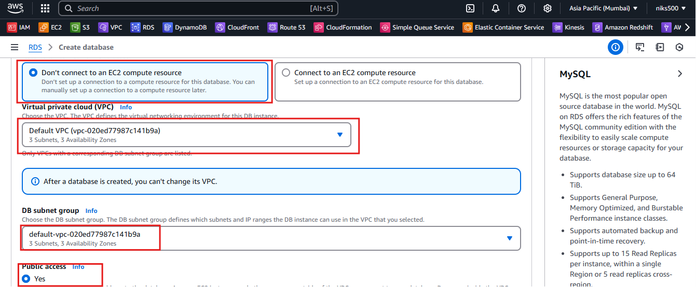

* + **VPC Security Group**: Create a new security group or select an existing one. Ensure the security group allows inbound traffic on **port 3306** (default for MySQL).
  + **Availability Zone**: Select an availability zone or let AWS choose.

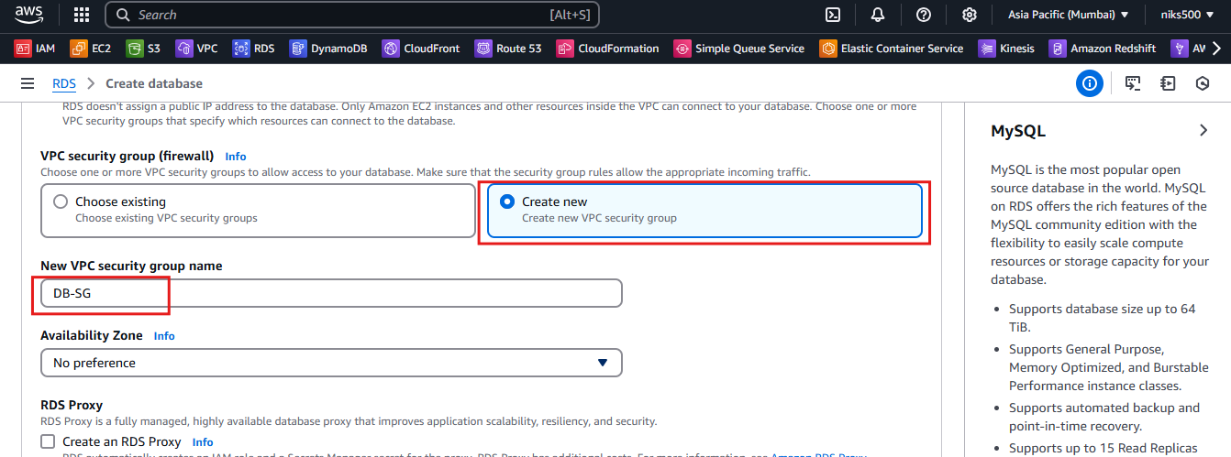

1. **Additional Configuration (Optional)**:
   * **Database Name**: You can set a default database name to be created when the instance is launched.
   * Leave other settings as default, or configure them as needed.
2. **Launch the RDS Instance**:
   * After reviewing your settings, click **Create database**. This process will take a few minutes.

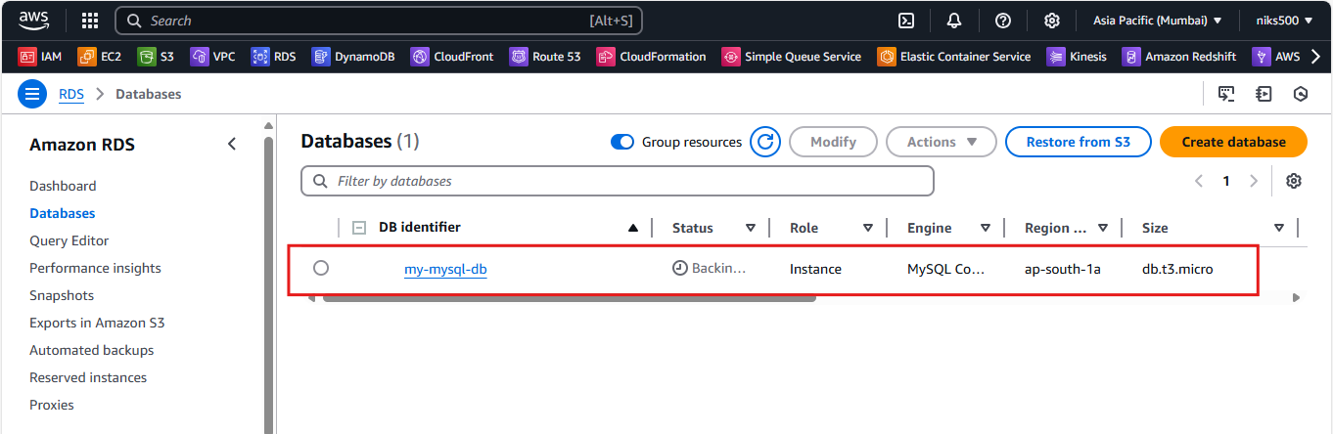

**Step 2: Modify Security Group to Allow Connections from Your IP**

1. **Navigate to EC2 Dashboard**:
   * In the AWS Console, go to the **EC2** dashboard.
2. **Modify Security Group**:
   * Under **Security Groups**, find the security group that is associated with your RDS instance.
   * Click on the security group and go to the **Inbound rules** tab.
   * Click **Edit inbound rules** and add a rule to allow **MySQL/Aurora** (port 3306) from your IP address. You can select **MySQL/Aurora** from the predefined list, or manually set the port 3306 and set **Source** to your IP address (0.0.0.0/0 for all IPs, but it's recommended to be more specific for security).

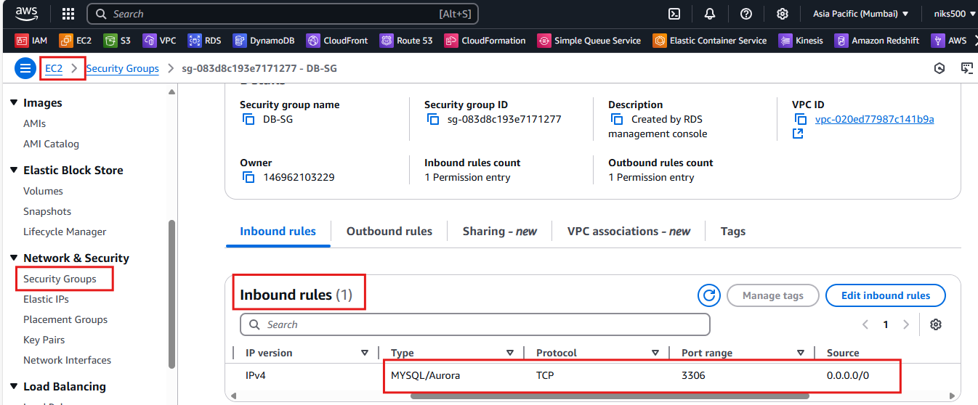

* + Save the changes.

**Step 3: Retrieve RDS Instance Endpoint**

1. Go to the **RDS Dashboard** in the AWS Console.
2. Click on **Databases** and select your RDS MySQL instance.

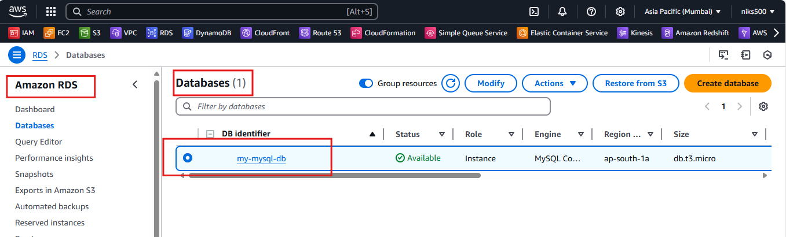

1. On the **Connectivity & security** tab, find the **Endpoint** (a URL like my-mysql-db.xxxxxxx.us-east-1.rds.amazonaws.com).

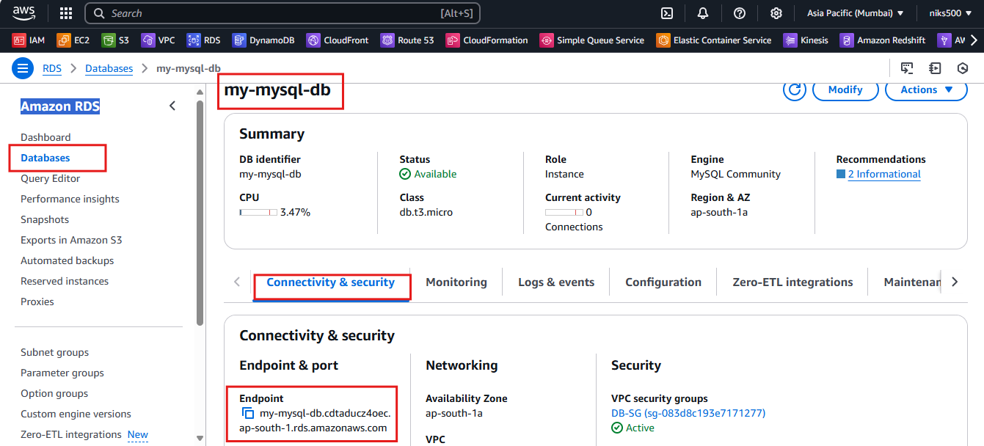

1. Note down this endpoint; you will need it to connect to the database in DBeaver.

**Step 4: Connect to the RDS MySQL Instance Using DBeaver**

1. **Open DBeaver**:
   * Launch the DBeaver application.
2. **Create a New Database Connection**:
   * Click the **New Database Connection** button (or press Ctrl+N).
   * Select **MySQL** from the list of database types. Click **Next**.

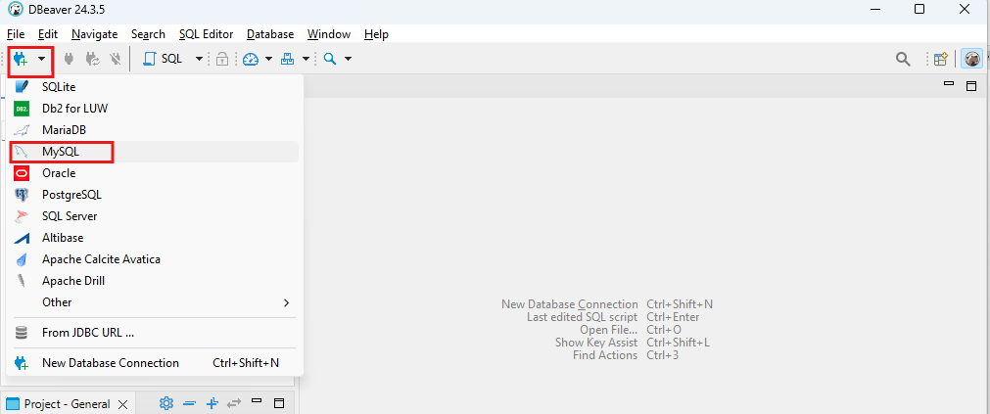

1. **Configure Connection Settings**:
   * **Host**: Enter the **Endpoint** URL of the RDS instance that you retrieved earlier (without the http:// or https://, just the hostname like my-mysql-db.xxxxxxx.us-east-1.rds.amazonaws.com).
   * **Port**: Enter **3306** (the default MySQL port).
   * **Database**: Enter the name of your database (if created during RDS setup) or leave blank to list all databases.
   * **Username**: Enter the **Master Username** (e.g., admin).
   * **Password**: Enter the **Master Password**.

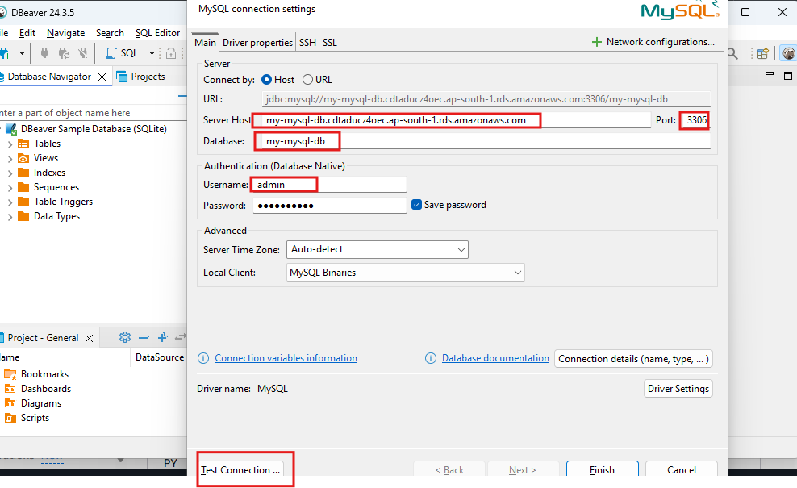

1. **Test Connection**:
   * Click the **Test Connection** button to verify if the connection is successful. If successful, DBeaver will indicate that the connection is OK.

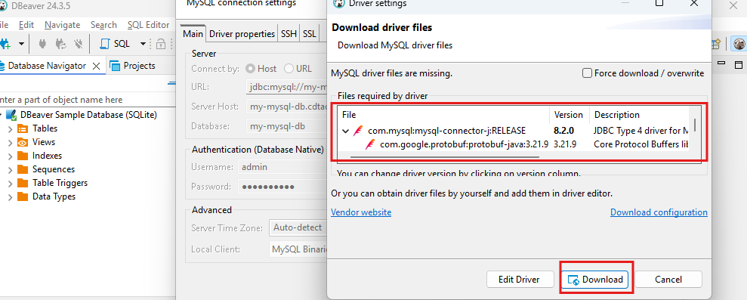

1. **Save the Connection**:
   * Once the connection is successful, click **Finish**.

